**Cube Bird**

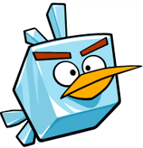Cube Birds appear in the base game in their corrupted form.

Cube birds have long pointy bills similar to that shown in the picture.  
They have wings about the size of one of their cubic faces.

Animations:

Cube birds fly horizontally around and nosedive once the player is underneath them.  
After a nosedive they recover and fly back up again to their regular pattern until they find the player underneath again.

They have little HP, but inflict a lot of damage.  
They are easily dodged when fought alone, but become an issue when the player is distracted with other enemies.